A000-Asia-China-*P’an* water vessel-Bronze-Late Western Zhou Dynasty-c 850-771 BCE

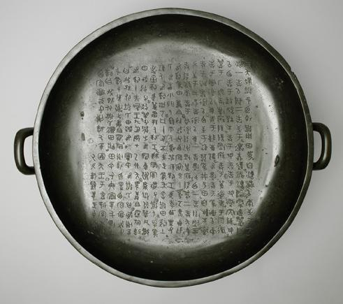

*P’an* water vessel-Bronze-Late Western Zhou Dynasty-c 850-771 BCE

**Accession No.**

**Formal Label:**

**Display Description:**

Inscribing on bronzes, either by casting or engraving, is a characteristic of Chinese bronzes which makes them very uniquely different from those made in other cultures.

The rich textual repertoire debuted with mostly clan or ancestor names during Shang and early Zhou, and around the mid-period of Western Zhou increasingly adopted the theme of "For Descendents to Forever Cherish", which gradually developed into a standard finishing statement for many inscriptions. Other contents also abounded: chronicles of military actions, dowries in marital unions, ceremonies of conferment and endowment, contracts for land ceding, edicts and awards, and so on. They serve as original records vividly documenting what was done and

**LC Classification:**

**Date or Time Horizon:**

**Geographical Area:**

**Map:**

**GPS coordinates:**

**Cultural Affiliation:**

**Media:**

**Dimensions:** h. 20.6 cm　 w. 54.6 cm.,

Case No.: 5

**Weight:**

**Condition:**

**Provenance:**

**Discussion:**

said, delivered in the vocabulary and diction of the time.

The golden inscriptions are the end results of a series of processes which involve engraving, molding, and finally casting, of the handwritten originals; yet the cast texts still manage to reenact the superb calligraphy of the time. The calligraphic styles reflect the gradual development and forming of da zhuan (large seal script), evolving from powerful spontaneity of Shang and early Zhou, to solemn regularity during the mid-period, Wesernt Zhou, and to refined smoothness from late Western Zhou to early Spring and Autumn period. That more and more long texts appeared during mid to late Western Zhou is also a live illustration of Zhou's "elaborate textual repertoire" "preserved in golden inscriptions".

**References:**

Taiwan National Museum, 故銅2376. After http://culture.teldap.tw/culture/plugins/content/fboxbot/thumbs/bronzes09_200x173_c38cea28c4e5976e62ae34f046d24703.jpg